Company Profile

VISTAR INFRATECH

BRIEF INTRODUCTION ABOUT THE COMPANY:-

VISTAR INFRATECH WAS ESTABLISHED IN YEAR 2014 AIMING TO CATER THE PRESENT DAY’S REAL ESTATE MARKET BY PROVIDING THE BEST CONSTRUCTION SERVICES.

THE COMPANY WAS ESTABLISHED BY TWO PARTNERS BHUPENDER GUPTA AND SHIV SAHNKER VERMA WHO HAD COMPLETED VARIOUS RESIDENTIAL AS WELL AS COMMERCIAL PROJECTS OF REKNOWNED COMPANIES.

BHUPENDER GUPTA IS A CIVIL ENGINEER BY PROFESSION WITH 24 YEARS OF EXPERINCE IN THE FIELD OF CONSTRUCTION OF RESIDENCIAL PROJECTS, HOTELS AND COMMERCIAL BUILDINGS.SHIV SHANKER VERMA IS A GRADUATE AND HAS A VASTE EXPERIENCE IN THE FIELD OF INTERIORS OF RESIDENTIAL AND WELL AS COMMERCIAL BUILDINGS.

THE COMPANY HAS ACHIEVED A TURNOVER OF Rs 2 CRORES IN STARTING YEAR 2015-16, RS 9 CRORE IN THE FINANCIAL YEAR 2016-17, 13.5 CRORES IN THE FINANCIAL YEAR 2017-2018, 13.65 CRORES IN THE FINANCIAL YEAR 2018-2019 AND 9.18 CRORE IN THE FINANCIAL YEAR 2019-2020.

OFFICE ADDRESS:-

REGISTERED OFFICE:-

VISTAR INFRATECH
2986, GALI NO 11, RANJEET NAGAR, NEW DELHI-110008.

BRANCH OFFICE:-

VISTAR INFRATECH
C-12/3 SECOND FLOOR, ARDEE CITY,
SECTOR -52, GURGAON.

OUR BANKERS:-

IDBI BANK, OMAXE MALL,
SECTOR 48, SOHNA ROAD, GURGAON.

PAN NO THE COMPANY

AALFV8584H

GSTIN NO: - 06AALFV8584H1ZH.

LIST OF MACHINERIES:-

- BATCHING PLANT OF 15 CUMT:- 1 NO

- CONCRETE PUMP:- 1 NO

- CONCRETE MIXERS OF CAPACITY 6 CUMT PER HOUR(GAMZENS) : 2NO’S

- CONCRETE MIXERS OF CAPACITY 3 CUMT PER HOUR:- 6 NO’S

- BUILDER HOISTS:- 5 NO’S

- BRICKS/MATERIAL LIFTING MACHINE:- 3 NO’S

- DG SET OF CAPACITY 7.5 KVA- 1 NO

- DG SET OF CAPACITY 15 KVA- 1 NO

- DG SET OF CAPACITY 40 KVA- 1 NO

- WATER PUMPING MOTARS:- 5 NO’S

- CONCRETE VIBRATORS-6 NO’S

12. WELDING MACHINES-2 NO’S

13. BAR BENDING MACHINE-3NO’S

14. BAR CUTTING MACHINE- 3NO’S.

LIST OF STAFF:-

- SR PROJECT MANAGERS:- 1

- PROJECT MANAGERS:- 3

- JR ENGINEERS(CIVIL)-4

- FOREMAN CIVIL -3

- SUPERVISORS-4

- ELECTRICIAN-4

- MECHANICAL FOREMAN-2

- STORE KEEPER:- 2

- SITE ACCOUNTANTS:- 1

- OFFICE ASSISTANTS:-2.

LIST OF PROJECTS COMPLETED.

S.NO | PROJECTS | ESTIMATED COST | YEAR OF COMPLETION | CONTACT PERSON
1. | CONSTRUCTION OF 804 RESIDENTIAL FLATS (AFFORDABLE HOUSES) INCLUDING AND COMMUNITY HALL OF PAREENA INFRASTRUCTURES PVT LTD IN SECTOR 99A,GURGAON,HARYANA | 54.06 CR | OCT 2021. | MR. MUKESH GUPTA  9818146886  .
2. | CONSTRUCTION OF FLOORS ON RESIDENTIAL PLOT OF 240 SQ YARDS IN Sector 52,GURGAON | 1.20 CR | DEC 2021 | MR K.D SHARMA  9810122681
3. | CONSTRUCTION OF GUEST HOUSE BUILDING ON PLOT OF 360 SQ YARDS IN SECTOR 43,GURGAON | 1.65 CR | DEC 2021 | Mr ASHWANI VASHIST.  9891156363.
4. | CONSTRUCTION OF FLOORS AND VILLAS AT SANTUR SILVER SPRING,SECTOR 35,KARNAL OF SANTUR GROUP,NEW DELHI. | 4.65 CR | NOV 2021 | Mr SHARAD JAIN  .
5. | CONSTRUCTION OF VILLA AT RESIDENTIAL PLOT OF 204 SQ YARDS IN SECTOR 43,GURGAON | 90 LAKHS | 2020 | MR SACHIN VERMA  9810047824
6. | CONSTRUCTION OF FLOORS ON RESIDENTIAL PLOT OF 263 SQ YARDS IN SECTOR52,GURGAON | 1.25 CR | 2020 | MR SUBODH GUPTA  9311227100
7. | CONSTRUCTION OF FLOORS ON RESIDENTIAL PLOT OF 240 SQ YARDS IN ARDEE CITY,GURGAON | 1.14 CR | 2020 | MR K.D SHARMA  9810122681
8. | INTERIOR OF RESIDENTIAL FLATS OF FRIENDS C.G.H.S LTD,MANASER  POP AND FALSE CEILEING WORK | 80 LACS | 2017 | MR ANIL ARORA.
9. | CONSTRUCTION OF FLOORS ON RESIDENTIAL PLOT OF 270 SQ YARDS IN PALAM VIHAR, GURGAON CITY. | 75 LACS | 2017 | MR K.D SHARMA  9810122681
10. | CONSTRUCTION OF FLOORS ON RESIDENTIAL PLOT OF 204 SQ YARDS IN ARDEE CITY, GURGAON. | 50 LACS | 2017 | MR RAJESH BHARDWAJ  9810017480.
11. | CONSTRUCTION OF FLOORS ON RESIDENTIAL PLOT OF 300 SQ YARDS IN ARDEE CITY, GURGAON. | 75 LACS | 2016 | MR RAJESH BHARDWAJ  9810017480.
12. | CONSTRUCTION OF FLOORS ON RESIDENTIAL PLOT OF 240 SQ YARDS IN ARDEE CITY, GURGAON. | 60.00 LACS | 2015 | MR. K.D SHARMA  9810122681

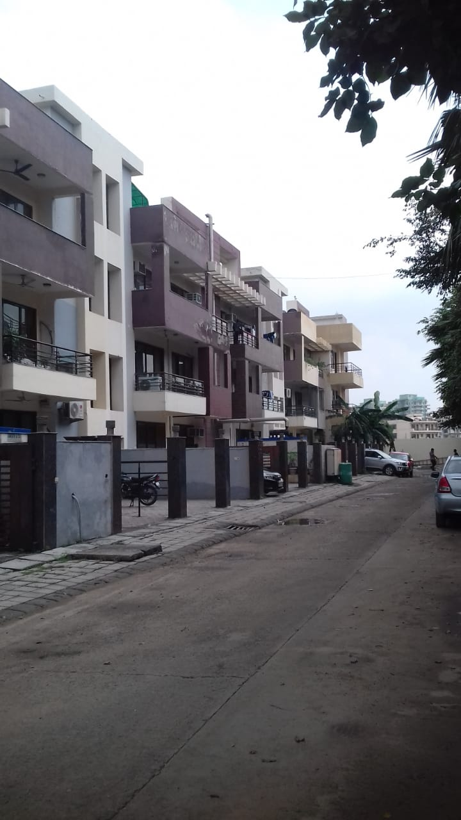

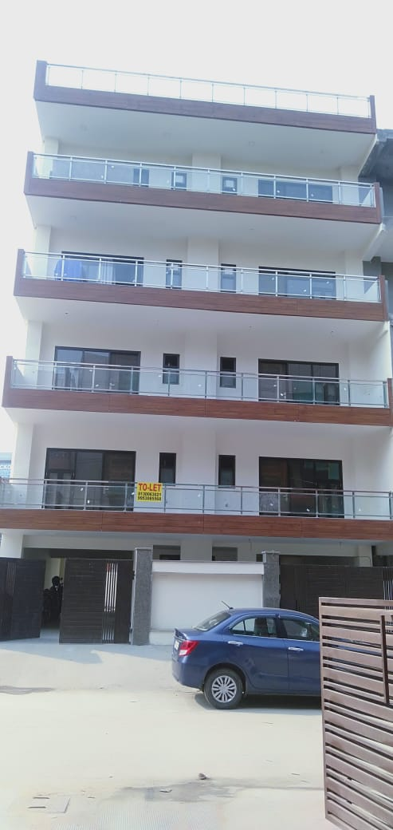

C-39, ARDEE CITY, SECTOR-52, GURGAON BELONGS TO Mr K.D.SHARMA.
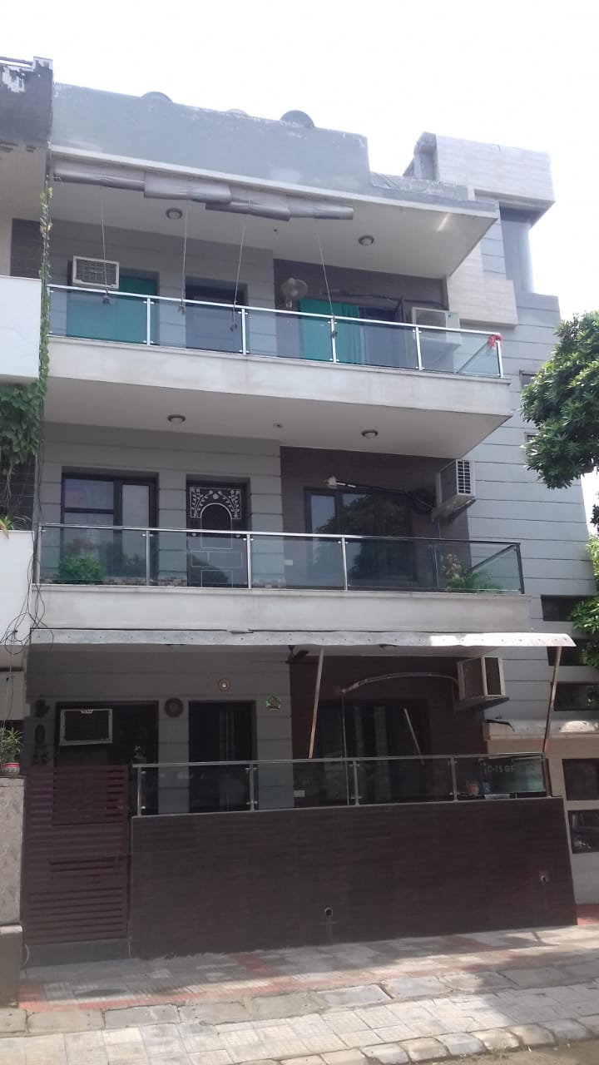

C-75,ARDEE CITY,GURUGRAM BELONGS TO Mr RAJESH BHARDWAJ.

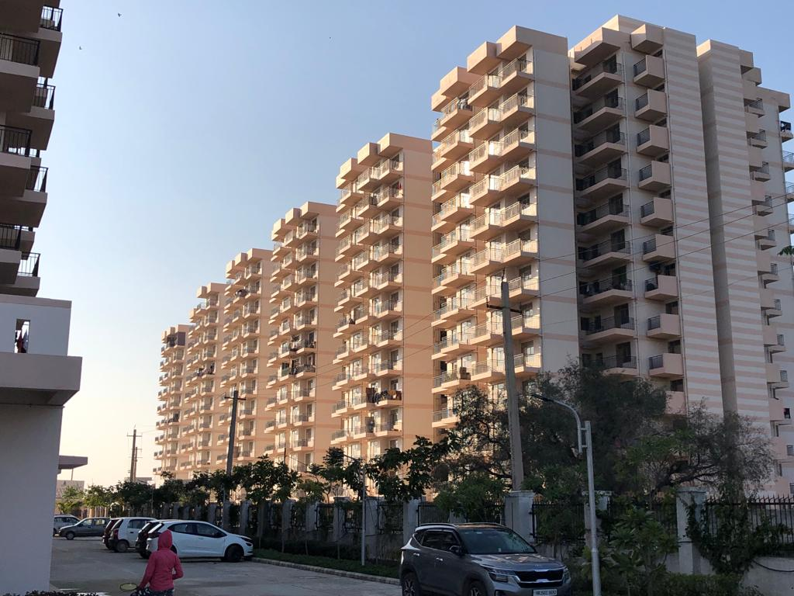

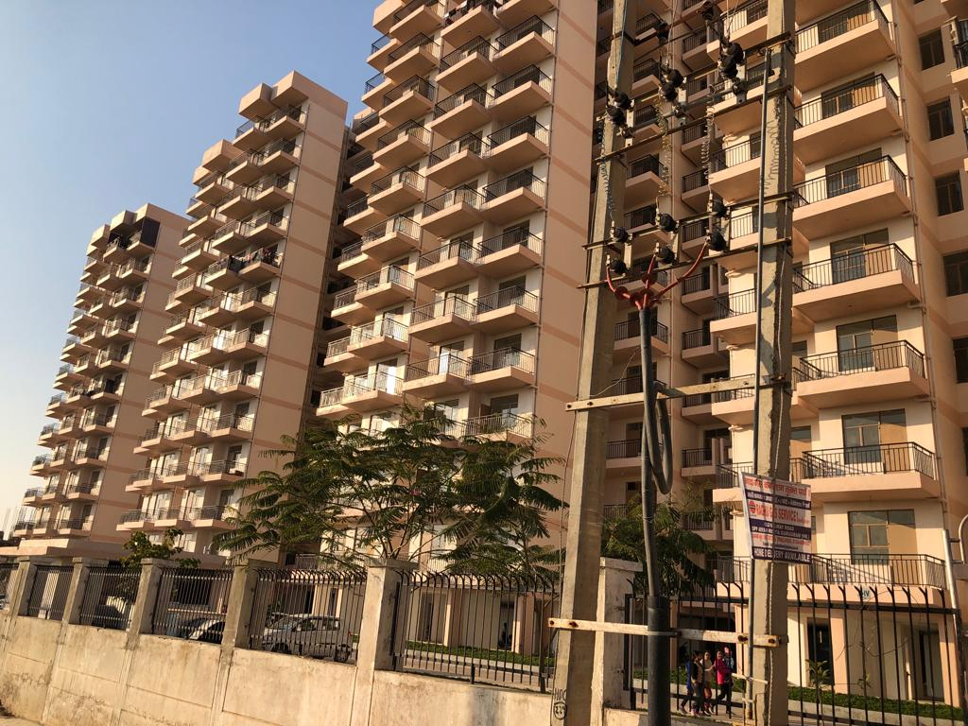
AFFORDABLE GROUP HOUSING –LAXMI APRTMENT,SECTOR 99A,GURUGRAM OF PAREENA INFRASTRUCTURE PVT LTD.

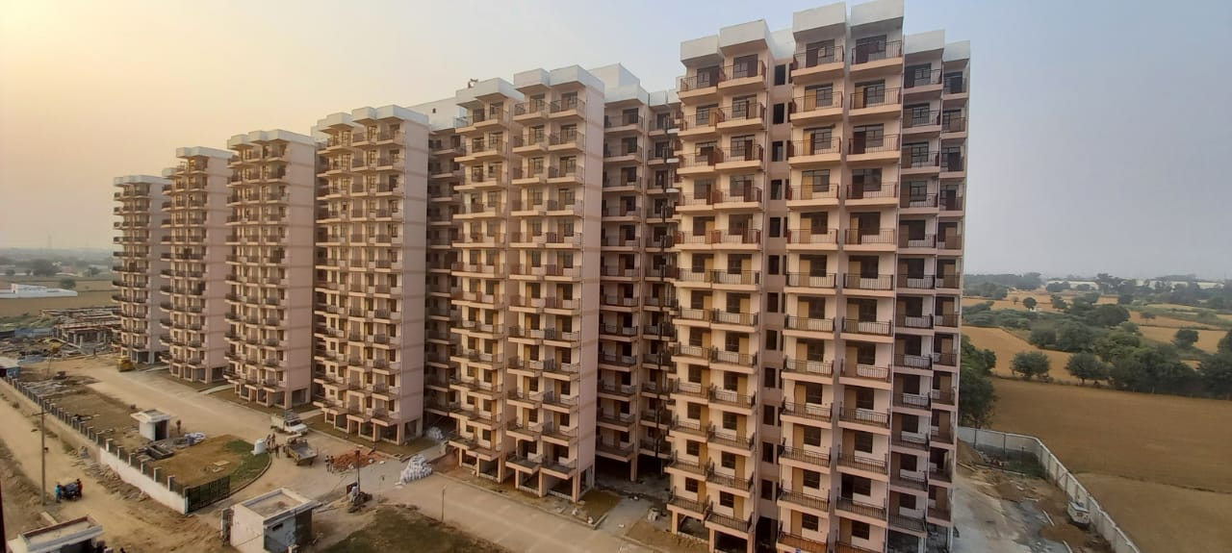

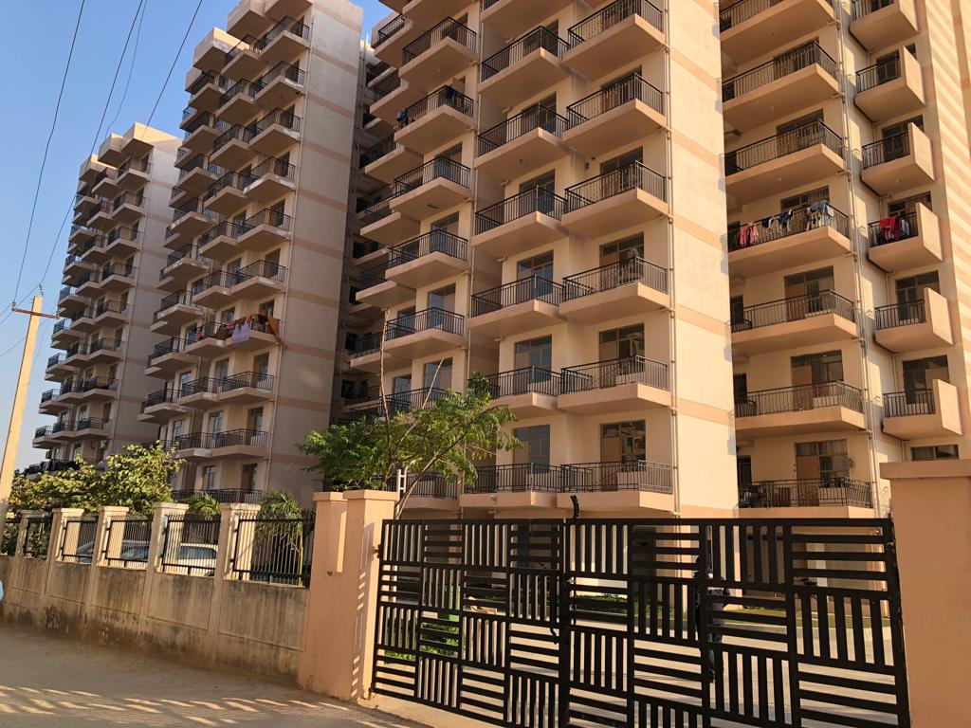

AFFORDABLE GROUP HOUSING –LAXMI APRTMENT,SECTOR 99A,GURUGRAM OF PAREENA INFRASTRUCTURE PVT LTD.

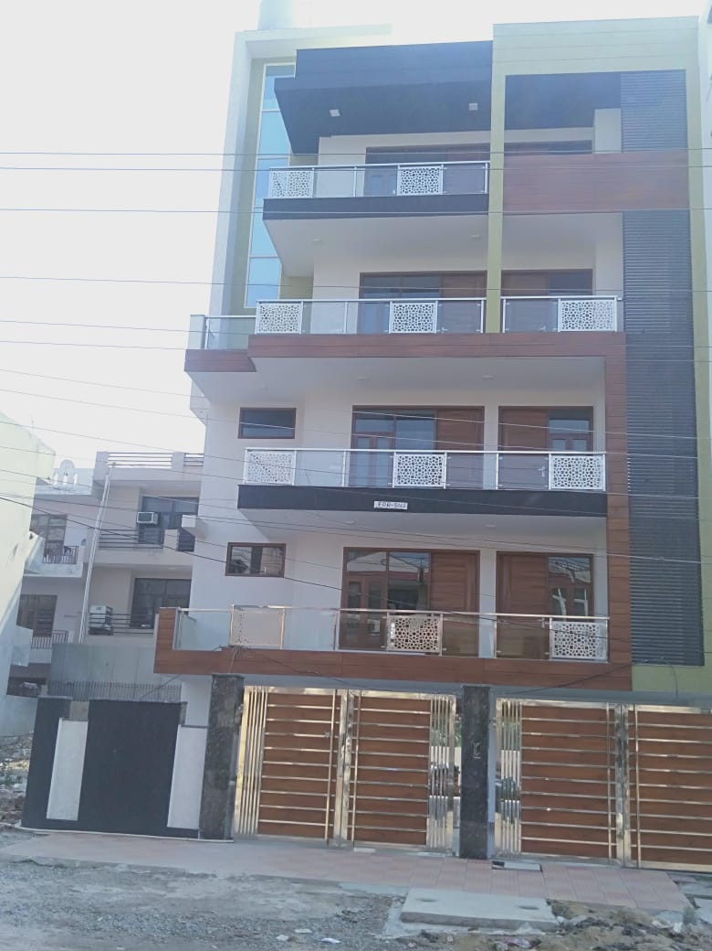

HOUSE NO-1241, SECTOR 52, BELONGS TO Mr. SUBODH GUPTA.

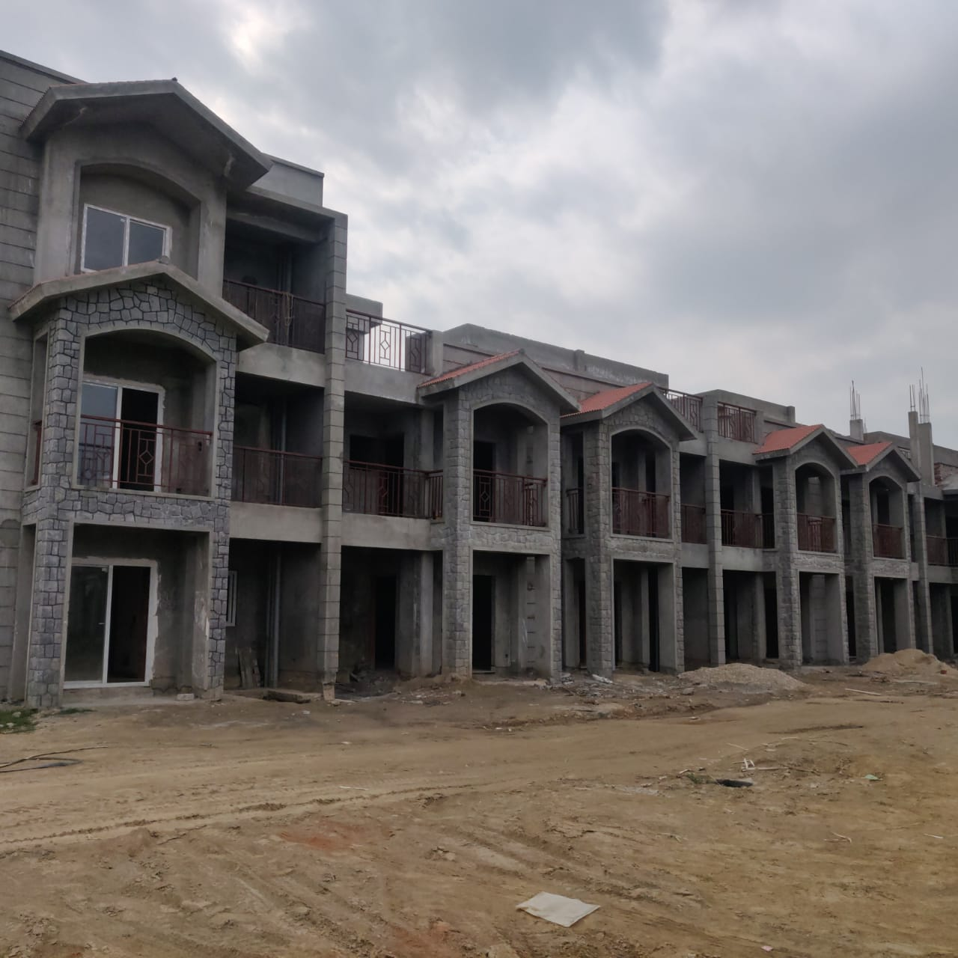

VILLAS
SANTUR SILVER SPRING, SECTOR 35, KARNAL
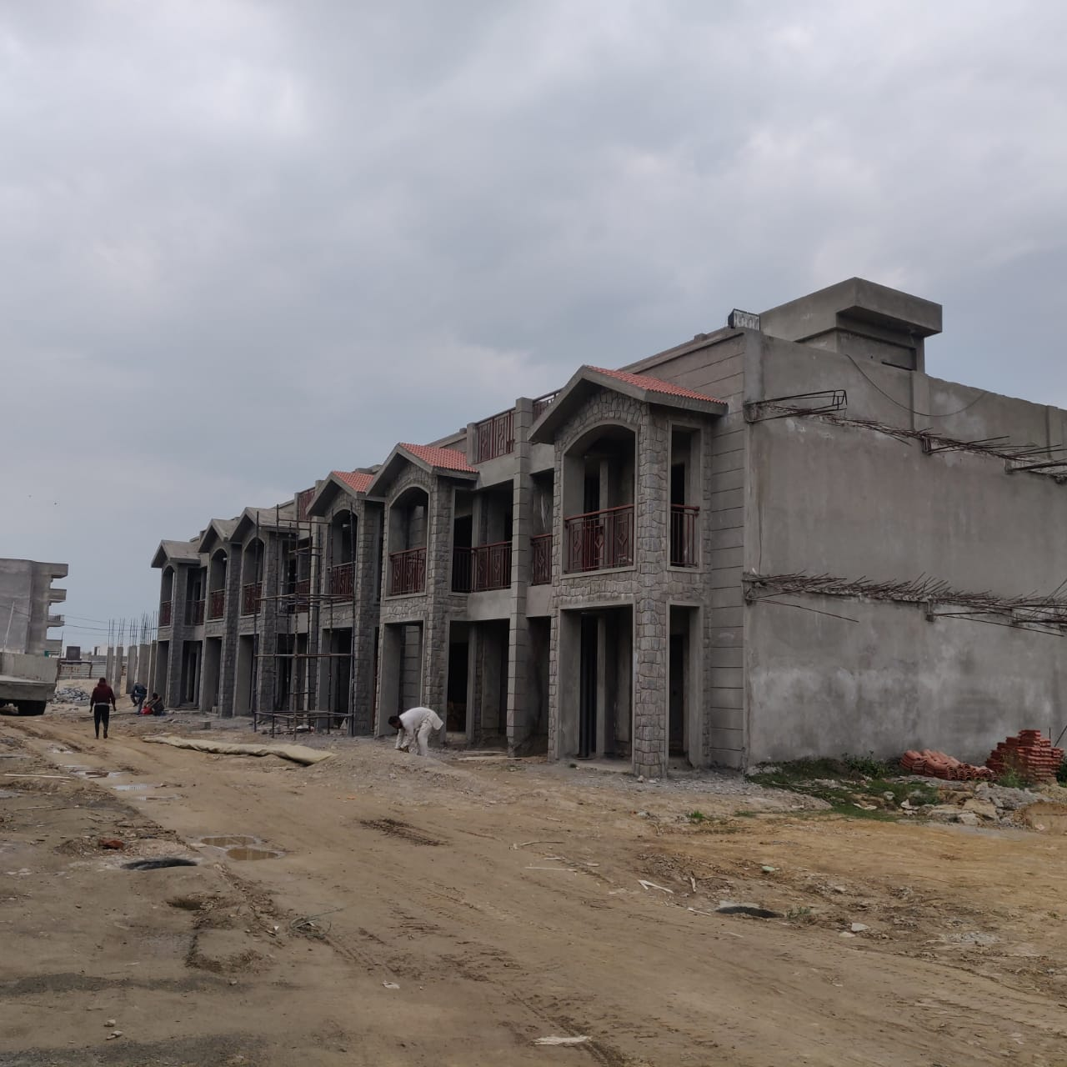
VILLAS
SANTUR SILVER SPRING, SECTOR 35, KARNAL.
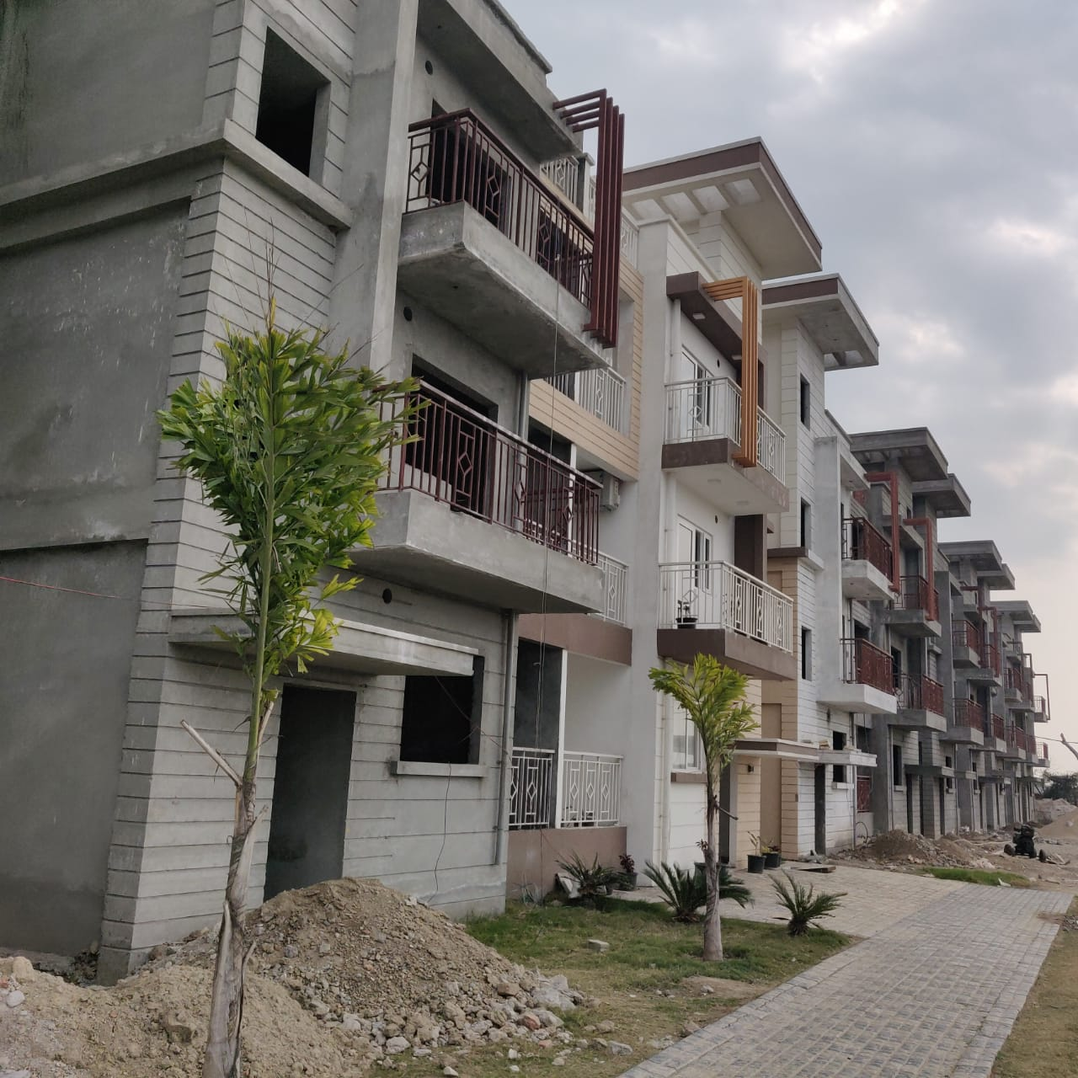

3 BHK FLOORS
SANTUR SILVER SPRING, SECTOR 35, KARNAL.

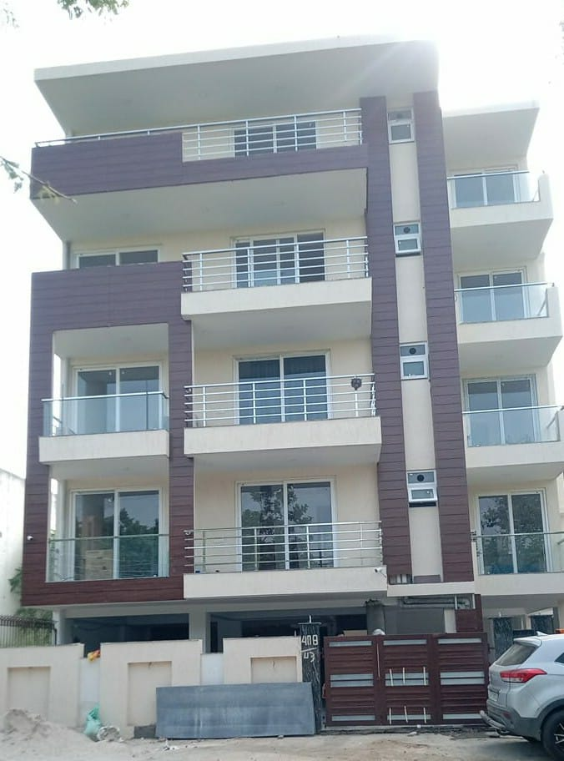

H. NO.- 488, SECTOR-43, GURGAON, HARYANA

Plotno 73,Sector 52,Gurgaon.
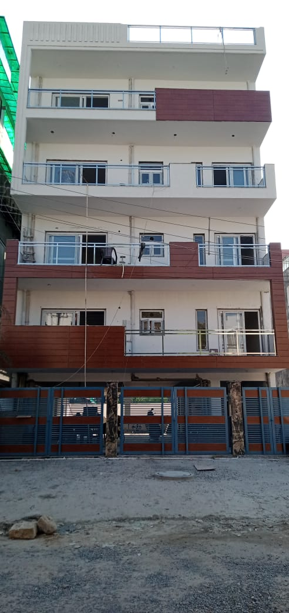

LIST OF PROJECTS IN HAND

S NO | PROJECT | ESTIMATED COST | YEAR OF COMPLETION | CONTACT PERSON
1. | CONSTRUCTION OF 33 RESIDENTIAL FLATS (AFFORDABLE HOUSES-3BHK) INCLUDING COMMERCIAL BUILDING OF PAREENA INFRASTRUCTURES PVT LTD IN SECTOR 99A,GURGAON,HARYANA | 3.72CRORE | OCTOBER 2022.  (50% COMPLETE) | MR. MUKESH GUPTA  9818146886  .
2. | CONSTRUCTION OF EWS APARTMENT 104 NO’S ON RESIDENTIAL GROUP HOUSING COMPLEX OF SHIV NANDAN BILDTECH, SECTOR 99, GURGAON. | 3.50 CRORE | AUG 2022. | MR. MUKESH GUPTA  9818146886
3 | CONSTRUCTION OF FLOORS ON RESIDENTIAL PLOT OF 192 SQ YARDS IN VIPUL WORLD. | 1.35 Crore | JUNE 2022 | Mr ATUL MITTAL.

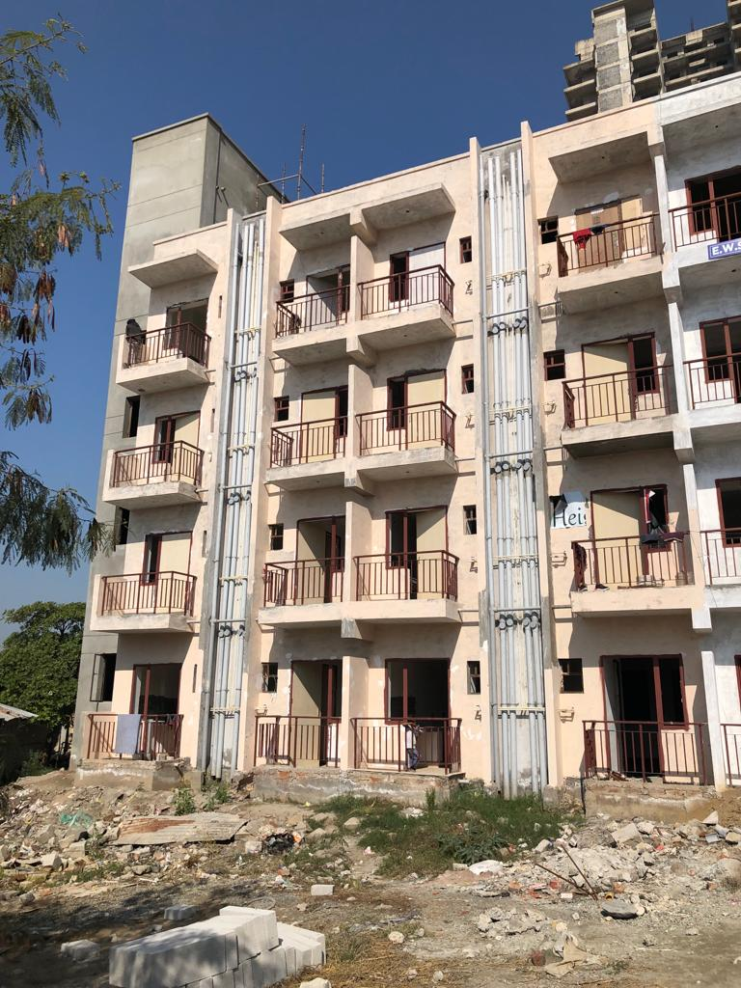

EWS FLAT AT EXPRESS HEIGHTS,SECTOR 99,GURGAON OF PAREENA INFRASTRUCTURES PVT LTD.

